GPS-TK118 User’s Manual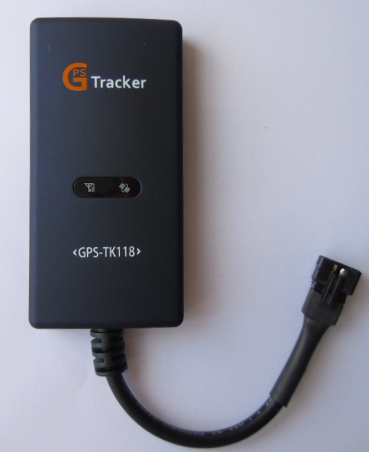

Welcome Thanks for using GPS-TK118 satellite positioning tracker
This tracker is a multi-functional GPS satellite positioning tracker device which can be applied to cars, electro cars, special vehicles, motorcycle and other vehicles. Wide scope power from 9V to 24V can be used to install. This product is small-sized and easy to carry, High sensitivity GPS and GSM module inbuilt, to make monitoring come true by sending messages or GPRS transmit the monitoring position to monitored platform or mobile phone. Only if you open the website of monitored platform can you monitor the target, no need to install any other software. The position can be monitored and track will be stored automatically online in real time, without any manual interference.
The instruction manual provides specific description for installation and usage of tracker. Please read the manual instruction carefully before using this product and use it correctly under the direction. Please keep the manual instruction after reading for unexpected needs.

Notice:
GPS receiver must receive signals from 3 satellites at least; otherwise it can’t locate position reliably. But indoors, underground parking, cavern and tunnels, GPS receiver may be unable to receive signals from satellites; it’s not caused by this product. Please try to use this product in places where the sky can be seen.
一． Applied range
- prevention of burglary and position for the scooter/motorcycle/vehicle/logistics industry/mechanical equipment
- outworker management
- criminal detection and hidden tracking
二． Basic functions
- network checking position
- mobile phone checking position
- location and tracking
- power on/off detection（optional）
- cut off the power of the car and alarm(needs built-in battery, optional)
三．Product feature
- Simple to use(Just controlling the cell phone)
- Easy installation, it will work when linking-up the power supply.
- Inquiry for the current address with real street name by telephone
- Easy to hide (built-in GSM and GPS antennas)

四、Hardware Description
1. Side

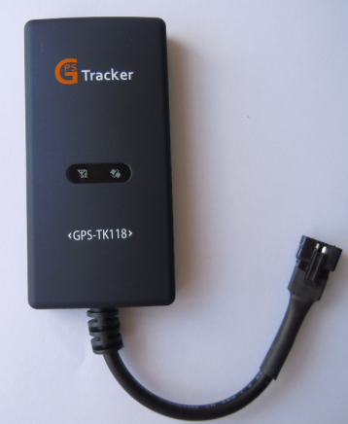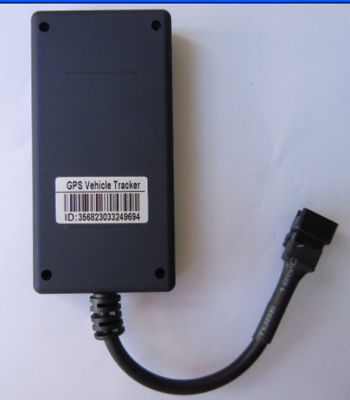
（positive） （opposite）

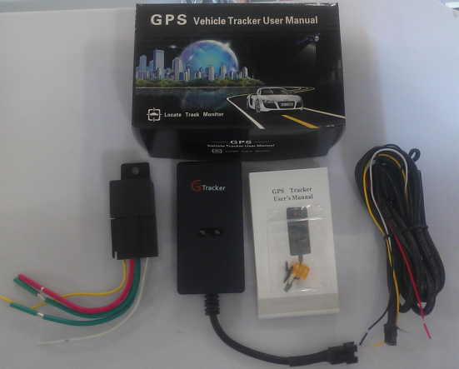

2.Wiring diagram:
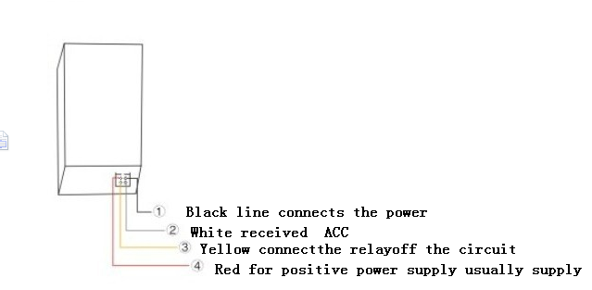
The relay by law:
85 feet by locator yellow line. Note; The yellow line equipment for negative triggered
86 feet by battery positive, note; This power must be often power supply, 12 v to within 24 v.
Will motorcycle to ignition coils of point the positive cutting, end 87 feet, A pick up relay by relay 30 feet at one end.

五、 Attentions
1. Insert a cell phone SIM card to the device
●Make sure the SIM card has opened the GPRS function, and the need set up the APN (ask the operator for the APN); otherwise the tracker will not work normally.
●Make sure the SIM card can call out and receive the SMS.
●Make sure the SIM card has no PIN number
●The device just supports GSM network SIM card, and does not support CDMA SIM card
2. SIM card installation schematic diagram

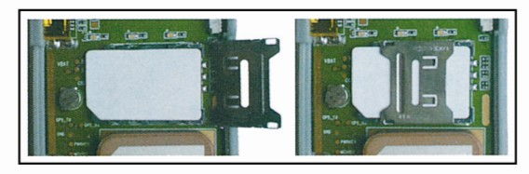

六、 parameter list

Name | Parameter
Dimensions | 97mm * 47mm * 12mm (main unit)
Communication network | GSM/GPRS
GSM module | GSM 850/900/1800/1900 MHz Quad frequency
GPS sensitivity | -159dBm
GPS positioning accuracy | 5-30m
Time accuracy | Synchronous with GPS
Voltage | DC 12~24V
Current | <80mA
Standby current | <10mA
Dust levels | IP6x
Water level | IPx5
Storage Temperature | -40°C to +85°C
Operating temperature | -20°C to +65°C
Humidity | 5%--95% non-condensing
LED indicator | 2 LED status display: GPS-blue, GSM-red

七 、Usages
- Terminal setting,（default password is 0000.）
1.1. Set the center number: #710#phone number#new password#old pass word##
For example：#710#13588888888#0000#0000##
When the command is sent, the center number will be：13588888888 and it will reply “CONFIG OK” to you cell phone， when the password is error, it will reply “PASSWORD ER”.

1.2．Set the administrator number:
Send command: #711#call1#call2#call3#User password##
Admin number is used for the tracker owner to set up the next 3 controlling numbers. Maximum is 3

For example: #711#13588888888###0000## (Set a license number)
#711#13588888888#13467510012##0000## (Set up two authorization number)
#711#13588888888#13467510012#13675144233#0000## ( Set three authorization number)

When the setting is successful, it will reply “CONFIG OK” when the pass word is wrong; it will reply “PASSWORD ER”

1.3．Changing the password :
Send command: #770#new password#User password##
Setting is done, the tracker will reply “CONFIG OK”，when the password is wrong will reply “PASSWORD ER”.
For example：#770#1234#0000##
when the command is executed，the password will change 0000 to 1234。
Notice: Please remember your new password, or will not control the device.

1.4 Regular Upload Interval Setup
Send command: # 730# Sampling interval # Pieces of uploads # User password ##
The defaulted factory upload interval of this device is 2 minutes for getting the point and 10 minutes for uploading one piece of positioning information. The user may change such parameter according to actual demand.
For example: 730#20#4#0000##
Note: The parameter “20” indicates getting one point every 20s; after getting points accumulatively for 4 times, upload one piece of positioning information with the upload interval as 20*4=80s. The user may change this parameter as the case may be.

1.5 Set APN Command
Send command: #802#APN letters or digits, 4-20 bits ### terminal password ##
and send it to the terminal; after executing this command, the terminal will automatically restart and connect to GPRS with APN set.
Command example 1: #802#cmnet###0000##
After this command is executed, APN will cmnet.
Note: The default APN of this product is CMNET.

2.Setting the alarm

2.1 Alarm format
Send command:#720#Warning way0-3#User password##
1 .Warning way0：Don't call the police
2. Warning way1：Dial-up alarm
3. Warning way2：Message alarm
4. Warning way3：Dial-up alarm and Message alarm
Example: #720#3#0000## After the implementation of this order,Module is set to dial up the way with text messages.If module in warned about the information at the same time also to perform the first number went to the default function.
the terminal will return the message of CONFIG OK to the setting mobile phone, or the message of PASSWORD ER if the password is wrong.
Note:The factory default alarm way for 0.

2.2 GPS Fence Function
Send command: # 751 # fence radius # sampling interval # longitude # latitude # user password ##.
For example: #751#500#5#22.5442N#113.91E#0000##
After the setup is successful, the setting mobile phone will receive a piece of config ok command. Then, when the ward leaves this area, the terminal will send the alarming information of being out of the fence to the center number.
Note: Send 9860000 reply of longitude and latitude this standard

2.3 Fence Reading Function
Send command: # 752 # user password ##
after the command is set successfully, the terminal will read the data of the module fence working status and return message to the sending mobile phone, or PASSWORD ER if the password is wrong.
For example: #752#0000##
Return: #open:1#lat:11456.209400#lng:2233.470100#distance:500#time:5#status:2
Where, open: 1 indicates fence open; Open: 0 indicates fence closed;
lat:11456.209400, latitude;
lng: 2233.470100; longitude;
distance: 500; fence radius;
time: 5 sampling interval;
status: 2 , terminal has obtained valid satellite data, fence works normally;
status: 1; fence open, but there are no valid satellite data have been received;
status: 0, no electronic fence is set.

2.4 Function of Canceling Fence
Send command: #760 # user password ##
Example: #760#0000##
After the terminal receiving this command, all fence settings will be cancelled.
Advice； Do not set GSM fence and GPS fence at the same time.

3. Control circuit:
A. Fuel cut
Send command: 222+password
For example: 2220000, the device will cut off the fuel, and then your cell phone will get a message “on” from the device.
B. Resume supporting the fuel
Send the command: 232+password
For example: 2320000 , the device will supply the fuel, and your cell phone will get a message “off” from the device.

七、Cell phone positioning
1.The admin number phone call the terminal, then hand up in 1-2 second, you will get a reply SMS with link.
2. Any call phone send 6660000 to the tracker; you will get a reply SMS with link.
3.Any call phone send 9860000 to the tracker; you will get a Google maps link
4. Mobile phone call with SIM card number administrator,Ring to 1-2 seconds hang up，you will get a goole map lind and Longitude latitude.( the sim Must open call display)
Example: you send 986000 to the tracker, you will get a reply SMS with link.

九. The status of the installation
1. Under the front windshield, hideout of the decorative sheet
2. Hideout of front dashboard
3. Under the back windshield, hideout of the decorative sheet
Notice: If the windshield has the metal thermal-protective coating, it will reduce the GPS signal and make it work abnormally.
The picture of the installation:

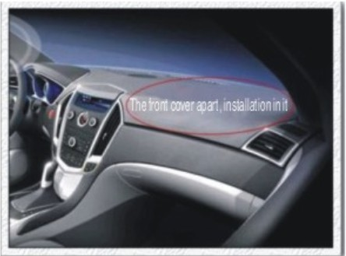

十. Auxiliary Function
Instructions | Explain
#710#centernumber # user password ## | Setup of Center Number
#711#admin cell phone number#password#serial number(1-9)## | Add admin number（can add nine number)
986+password | Reply to Google maps link
666+password | Location Inquiry
# 730# Sampling interval # Pieces of uploads # User password ## | Regular Upload Interval Setup
#770# User new password # User old password ## | Function of Changing Password
#802#APN###User password ## | Set APN Command
#803#FixedIPaddress#portnumber#4-digit password## | Setup of Server Address
# 751# fence radius # sampling interva）# longitude # latitude#user password ## | Set fence format
# 752# user password 4 digits ## | Fence Reading Function
# 760 # user password 4-digits ## | Function of Canceling Fence
#901## | Command of inquiring machine parameters
#902## | Command of inquiring GPRS parameter
#904## | GPRS connection command
#905## | GPRS disconnection command
#918## | Open AGPS
#919## | closedAGPS

